

40.018 Heuristics & Systems Theory

Project Report
ESD, Term 5, Class 1
May/June 2025
Student Name | Student ID number | Contributions
Neo Yew Young | 1004900 | Drafted initial problem statement and formulation
Wang Zheng Da | 1007659 | Wrote final report
Darryl Yap Jun Wei | 1007846 | Coder for simplified problem

1. Introduction

1.1 Problem background
Route design for public buses is a real-world application of routing problems like the Travelling Salesman Problem (TSP). Mathematically, one bus route is technically enough to cover a set number of bus stops. However, in practice, the bus cycle is too slow for passengers due to long wait times.

1.2 Problem Statement
The objective is to design multiple efficient bus routes to serve a fixed number of stops while minimizing total travel distance.

1.3 Challenges
The problem of designing optimal bus routes is fundamentally a combinatorial optimization problem, and specifically a generalization of the well-known Travelling Salesman Problem (TSP), which is classified as NP-hard. This implies that the number of possible solutions grows exponentially with the number of bus stops, making it computationally infeasible to solve exactly for large instances. In the classical TSP, the task is to determine the shortest possible route, visiting all locations once and returning to the starting point. Our formulation extends this to a multi-TSP (or k-TSP), where stops must be divided among multiple routes, and each route must independently form a tour.
This additional layer of complexity introduces two major sources of combinatorial growth: (1) the number of ways to assign bus stops to n different routes, and (2) the number of possible tour permutations within each route. For example, with 50 stops and 3 routes, the number of feasible combinations becomes astronomically large. As such, exact solvers like Gurobi must contend with thousands of binary decision variables and constraints, and explore an exponentially growing search tree using branch-and-bound techniques.
Although Gurobi is a state-of-the-art solver capable of producing provably optimal solutions, it often becomes computationally expensive as the problem size grows. When a time limit is imposed (e.g., 300 seconds), Gurobi may only find a feasible solution without proving optimality, or it may return a lower bound on the best achievable objective value. This limitation highlights the scalability challenge of exact methods for real-world-sized problems, motivating the use of metaheuristic approaches such as Genetic Algorithms for large instances.

1.4 Our Contribution
In consideration of the previous concerns, we propose a Genetic Algorithm (GA) with customised operators to efficiently solve this problem, and benchmark its performance.

2. Formulation
This problem is a modification of the Travelling Salesman Problem, where instead of a single tour, the objective is to optimise multiple bus routes to minimise the total distance across all bus routes.

2.1 Sets & Indices
The Python code from Appendix A1.1 is translated into mathematical formulation here:
- Q: Total number of bus stops (indexed by i, j ∈ {0,1,...,Q−1}
- n: Number of bus routes (indexed by k ∈ {0,1,...,n−1}

2.2 Parameters
$d_{i,j} = \sqrt{(x_{i}-x_{j})^{2}+(y_{i}-y_{j})^{2}}$: The Euclidean distance between bus stops i and j, calculated from their coordinates.

2.3 Decision variables
The Python code from Appendix A1.2 is translated into mathematical formulation here:
- x_{i,k} ∈ {0, 1}: A binary variable, where 1 indicates an assignment of bus stop i to bus route k., and 0 otherwise.
- y_{i,j,k} ∈ {0, 1}: A binary variable, where 1 indicates that route k includes a directed edge from bus stop i to j, and 0 otherwise.
- r_{k} ∈ {0, 1}: A binary variable, where 1 indicates that if route k is used (i.e., has assigned stops), and 0 otherwise.

2.4 Constraints
The Python code from Appendix A1.2 is translated into mathematical formulation here:
- Independent routes: Each stop is assigned to exactly one route:
$\sum_{k=0}^{n-1}{}[x_{(i,k)}]=1, ∀i ∈ \{0, ... ,Q-1\}$
- Degree constraints for each stop in a route: If a stop i is assigned to route k, then it must have exactly one incoming and outgoing edge in that route:
$\sum_{j=0,i≠j}^{Q-1}{}[y_{(i,j,k)}{=x}_{(i,k)}], ∀i ∈ \{0, ... ,Q-1\},∀k ∈ \{0, ... ,n-1\}$
$\sum_{j=0,i≠j}^{Q-1}{}[y_{(j,i,k)}{=x}_{(i,k)}], ∀i ∈ \{0, ... ,Q-1\},∀k ∈ \{0, ... ,n-1\}$
- Force all routes to be used: This enforces that each route must be marked as “used” (r_{k} = 1).
$\sum_{k=0}^{n-1}{}[r_{k}]=n$
- Minimum number of stops per used route: If route k is used, it must serve at least 3 stops (Minimum number of stops needed for a cycle):
$\sum_{i=0}^{Q-1}{}[x_{(i,k)}≥(3×r_{k})],∀k ∈ \{0, ... ,n-1\}$
- Maximum number of stops per route: If route k is not used, no stops can be assigned. If used, it can serve up to Q stops:
$\sum_{i=0}^{Q-1}{}[x_{(i,k)}≤(Q×r_{k})],∀k ∈ \{0, ... ,n-1\}$
- Edge count equals number of assigned stops: The number of directed edges used in route k must match the number of stops assigned to it (forming a TSP loop):
$\sum_{i=0,j=0,i≠j}^{Q-1}{}[y_{(j,i,k)}]=\sum_{i=0}^{Q-1}{}[x_{(i,k)}],∀k ∈ \{0, ... ,n-1\}$
- Minimum route length: The sum of all edges in a route must be more than a certain value (In this case, we set it to 8000). This replicates realistic concerns of avoiding trivial or overly short loops.
$\sum_{i=0,i≠j}^{Q-1}{}\sum_{j=0}^{Q-1}{}[d_{(i+1)(j+1)}×y_{i,j,k}]≥8000 ∀k$

2.5 Objective function
Minimise the total travel distance of all routes: $min\sum_{k=0}^{n-1}{}\sum_{i=0,i≠j}^{Q-1}{}\sum_{j=0}^{Q-1}{}[d_{(i+1)(j+1)}×y_{i,j,k}]$

2.6 Overall formulation
$min\sum_{k=0}^{n-1}{}\sum_{i=0,i≠j}^{Q-1}{}\sum_{j=0}^{Q-1}{}[d_{(i+1)(j+1)}×y_{i,j,k}]$
Constraints
- $\sum_{k=0}^{n-1}{}[x_{(i,k)}]=1, ∀i ∈ \{0, ... ,Q-1\}$
- $\sum_{j=0,i≠j}^{Q-1}{}[y_{(i,j,k)}{=x}_{(i,k)}], ∀i ∈ \{0, ... ,Q-1\},∀k ∈ \{0, ... ,n-1\}$
$\sum_{j=0,i≠j}^{Q-1}{}[y_{(j,i,k)}{=x}_{(i,k)}], ∀i ∈ \{0, ... ,Q-1\},∀k ∈ \{0, ... ,n-1\}$
- $\sum_{k=0}^{n-1}{}[r_{k}]=n$
- $\sum_{i=0}^{Q-1}{}[x_{(i,k)}≥(3×r_{k})],∀k ∈ \{0, ... ,n-1\}$
- $\sum_{i=0}^{Q-1}{}[x_{(i,k)}≤(Q×r_{k})],∀k ∈ \{0, ... ,n-1\}$
- $\sum_{i=0,j=0,i≠j}^{Q-1}{}[y_{(j,i,k)}]=\sum_{i=0}^{Q-1}{}[x_{(i,k)}],∀k ∈ \{0, ... ,n-1\}$
- $\sum_{i=0,i≠j}^{Q-1}{}\sum_{j=0}^{Q-1}{}[d_{(i+1)(j+1)}×y_{i,j,k}]≥8000 ∀k$

2.7 Description of data and preprocessing steps
The bus stop locations had randomly generated x-coordinate and y-coordinate points, each ranging between 0 and 10000 units, which were exported into a separate Excel workbook as per assignment requirements, and for ease of verifying bus stop locations. Meanwhile, the number of bus stops and bus routes is predetermined by us, and we would solve the problem for different combinations of bus stop and bus route sizes.

3. Genetic algorithm metaheuristic
Genetic Algorithms (GAs) are population-based metaheuristics inspired by the process of natural selection. They work by evolving a population of candidate solutions over successive generations using biologically-inspired operators such as selection, crossover, and mutation. GAs are especially effective in tackling complex optimization problems where the search space is large and nonlinear. In essence, it is an approximate algorithm that exploits a population of candidate solutions to converge into higher quality solutions.
We used Genetic Algorithms (GA) as our main metaheuristic method, since the Travelling Salesman Problem (TSP) and its multi-route variant are known to be NP-hard, meaning that the time required to find exact solutions grows exponentially with problem size. While exact solvers like Gurobi can be used for small to medium instances, they quickly become computationally expensive as the number of stops increases. Genetic Algorithms offer a scalable, flexible approach that can efficiently generate high-quality solutions within practical time limits.
Below is a comprehensive summary of the GA metaheuristic design choices.

3.1 Solution representation
In order to apply the metaheuristic effectively, an appropriate encoding of the solution is crucial for the algorithm to explore new solutions in the search space, exploit existing ones for convergence to local optima, and to uphold feasibility under the problem context. We chose a combination of two lists to uphold the solution structure: a permutation list of bus stops and a partition list for bus routes.

The permutation list supports the traditional TSP features of our problem by encoding the specific order in which bus stops must be visited, while the partition list encodes the bus route assignments by specifying the first few stops for bus route 1, the next few for bus route 2, and so on, according to the number of bus routes we have specified.
- An example for 7 bus stops and 2 bus routes: ( (7, 5, 3, 4, 6, 2, 1), (4, 3) )
  - Bus route 1 takes the first four bus stops: (7, 5, 3, 4)
  - Bus route 2 takes the next three bus stops: (6, 2, 1)

3.2 Initial population generation
To generate a diverse set of high-quality initial solutions, we employed a greedy nearest-neighbor heuristic to construct 100 candidate permutations, paired with fixed partition sizes for the route assignments. For each candidate, a random starting bus stop is selected, and the route is sequentially extended by connecting to the nearest unvisited stop until all stops are included. The corresponding partition list is generated with evenly distributed route sizes: the first Q % n routes receive (Q // n) + 1 stops, and the remaining n - (Q % n) routes receive (Q // n) stops.

3.3 Fitness function
Evaluation of the candidate solutions is done by means of a fitness value, which is the inverse of the total distance of all bus routes in the solution. This was done so that lower distances would equate to higher fitness values, indicating a superior candidate solution.

The algorithm calculates total distances by first segmenting the permutation list of bus stops into their assigned bus routes by the partition list. Then, it would sum the Euclidean distances between consecutive bus stops within each bus route, and add them up for all existing bus routes. A large penalty (1×10¹⁰) is added to the distance calculation if a route segment has fewer than 3 stops, to discourage such undesirable solutions.

3.4 Selection strategy
After evaluating the fitness value of candidate solutions, a selection strategy is needed to select ideal “parent” solutions. Our algorithm uses tournament selection, where max(2, Q // 3) solutions are placed into a “tournament”, and the solution with highest fitness value is selected within the tournament. The specific tournament size ensures a minimum of 2 participants even for fewer bus stops. This tournament is repeated two times to select two “parent” solutions for the next step.

3.5 Crossover strategy
Crossover strategies are applied to the permutation and partition lists of the two “parent” solutions to generate one “offspring” solution, akin to how DNA from parents are mixed into their offspring.

For the permutation list, order crossover is applied. A random segment from one parent is selected and directly copied into the offspring's corresponding segment. The remaining elements of the offspring are then filled in the order they appear in the second parent, ensuring that no duplicate bus stops are included and maintaining the permutation structure.

For the partition list, a blending/arithmetic crossover is applied. A random split point is chosen, and parts of the parent partition lists are combined. A crucial repair function is then applied to ensure the offspring's partition list when summed equals the number of bus stops and all route sizes are at least 3 for valid bus routes.

3.6 Mutation strategy
Afterwards, the mutation strategy is applied to “genetically mutate” or alter the “offspring” solution. Both permutation and partition lists have a 30% probability of mutating to encourage moderate exploration of the search space without disrupting existing solutions excessively.

For the permutation list, inversion mutation is applied. A random segment is selected and the order is inverted.

For the partition list, a custom mutation operator is applied. Two partition sizes are randomly selected, where one will increase by k and the other decreases by k, and k is an integer that can be 1 or more. This is a disruptive mutation that is necessary to encourage solution exploration.

3.7 Replacement strategy
After the “offspring” solutions are generated, a replacement strategy is necessary to maintain the population size and prevent an overgrowing number of candidate solutions. We chose an elitism strategy for our algorithm, where the single best solution from the current generation (or the best ever found if better) is directly carried over to the next generation, replacing the worst solution in the newly generated population. This is useful for tracking the best solution per generation and without discarding it.

3.8 Termination criteria
Finally, the algorithm stops running after a specified time limit. This could range from 60 seconds (1 minute) for small-scale experiments to 3600 seconds (60 minutes) or beyond for large-scale experiments. The time limit we specify depends on the scale of the number of bus stops and bus routes that the problem is running on.

4. Numerical experiments
Our alternative algorithm used was the Gurobi Solver, which uses the Simplex method with Branch and Bound heuristics to explore basic feasible solutions based on the constraints from the problem formulation.
To evaluate the performance of our Genetic Algorithm (GA), we conduct two sets of numerical experiments using the same model setup and randomly generated bus stop coordinates.
- A small-scale benchmark where Gurobi was able to find the optimal solution quickly, used to verify that our GA can closely match optimal performance.
- A larger-scale experiment where Gurobi could only find a suboptimal feasible solution within the time limit, used to demonstrate GA’s performance under more realistic, computationally intensive settings.

4.1 Small-scale benchmark: (Q=50, n=3)
This problem size is small enough for the Gurobi solver to reach the optimal solution within a reasonable time. We use it to validate the correctness and effectiveness of the GA.
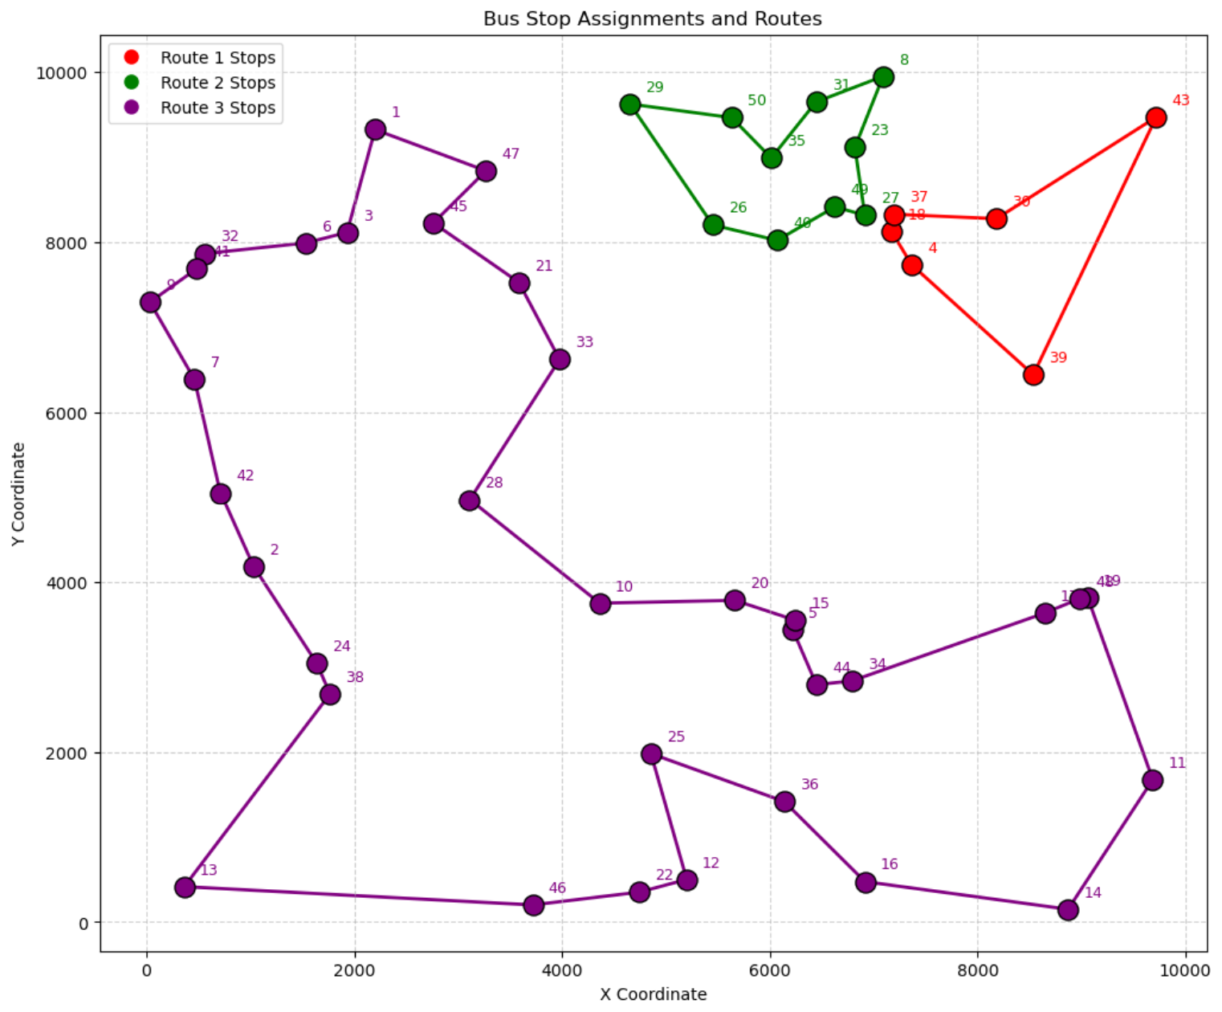
Figure 1: Solution for route maps by Gurobi Solver for small-scale experiment
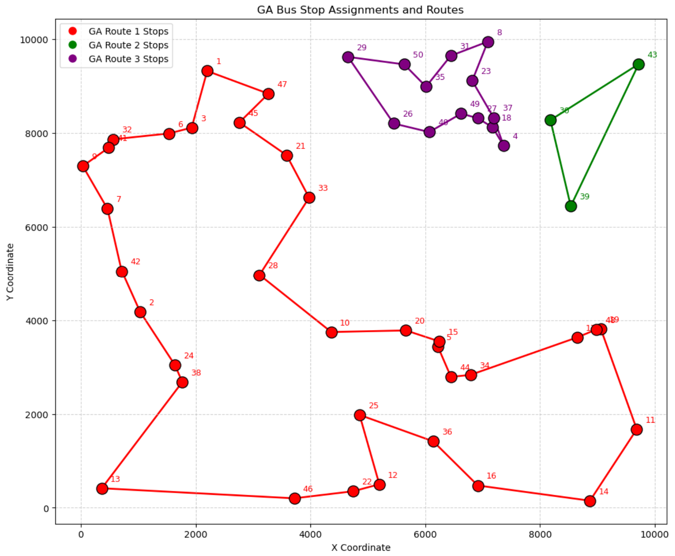
Figure 2: Solution for route maps by GA for small-scale experiment

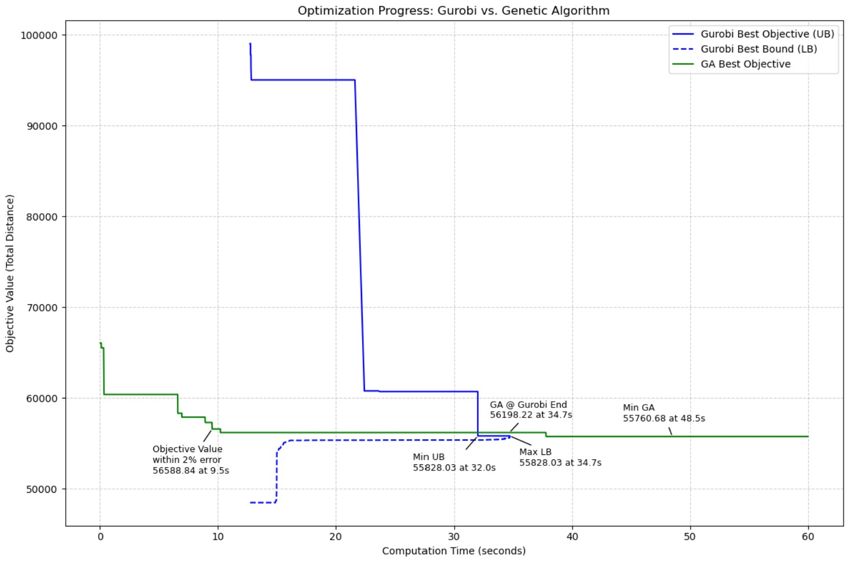
Figure 3: Objective values over time from Gurobi Solver and GA for small-scale experiment

Metric | Gurobi (Exact Solver) | GA (Metaheuristic)
Best Objective | 55,828.03 | 56,198.22
Time to Reach Best | 34.7s | 34.7s
Gap to Best Known | 0% | +0.7%
Table 1: Performance comparison between Gurobi and GA for small-scale experiment

The GA was able to find a high-quality solution very close to the exact optimum, demonstrating its validity for this type of routing problem. Both solvers converged early, and the GA’s error margin was under 1%, which is acceptable for a heuristic.

4.2 Large-scale benchmark: (Q=60, n=3)
This scenario increases the problem size and complexity. Gurobi is limited by a time cap of 3600 seconds (60 minutes), after which it may only report a feasible but suboptimal solution. GA will also run with the same time cap for fair comparison.
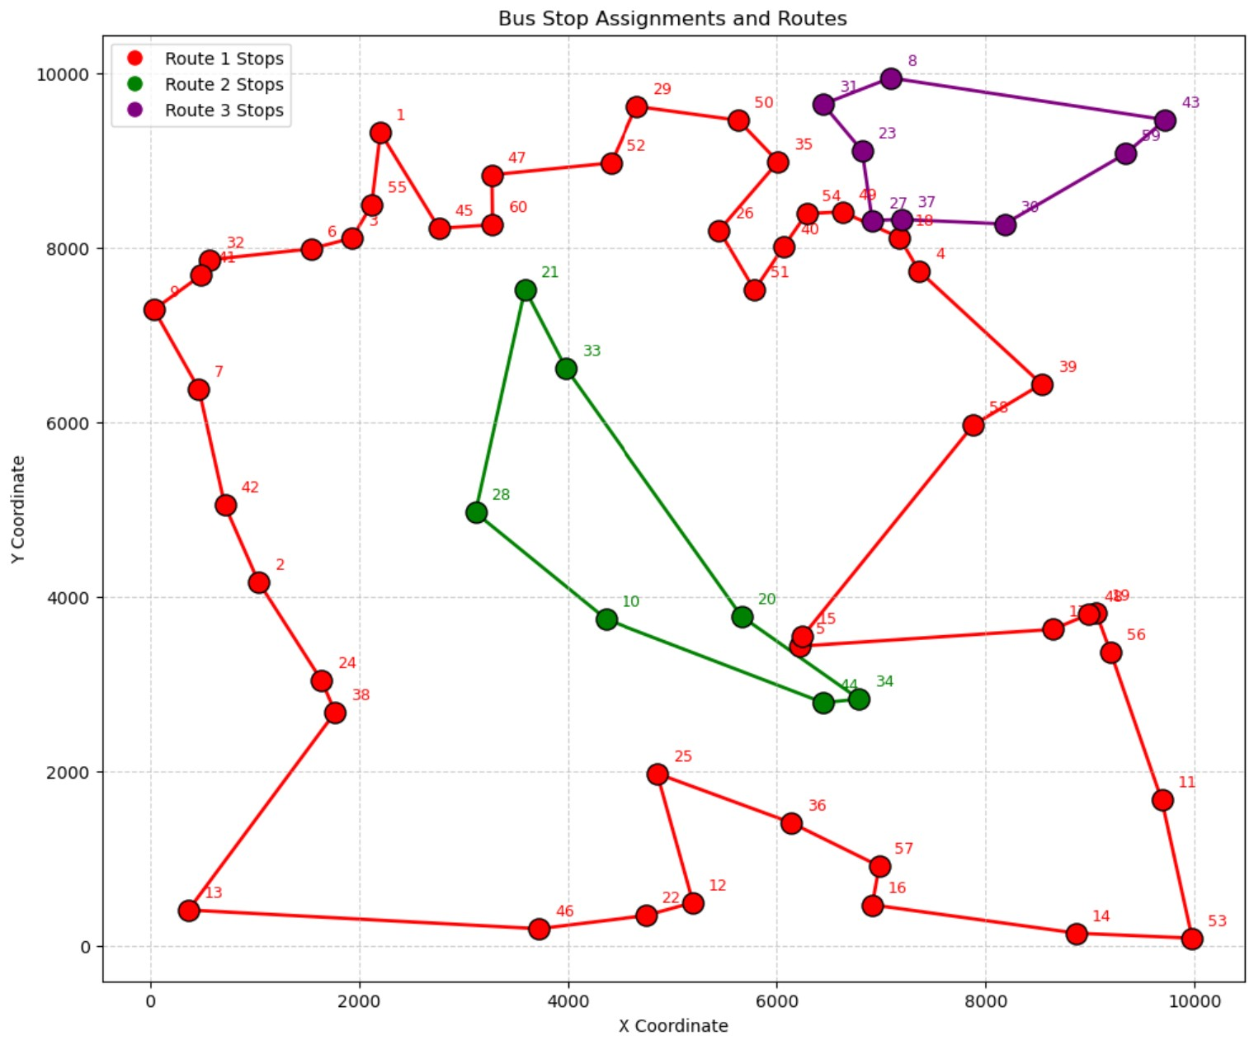
Figure 4: Solution for route maps by Gurobi Solver for large-scale experiment.
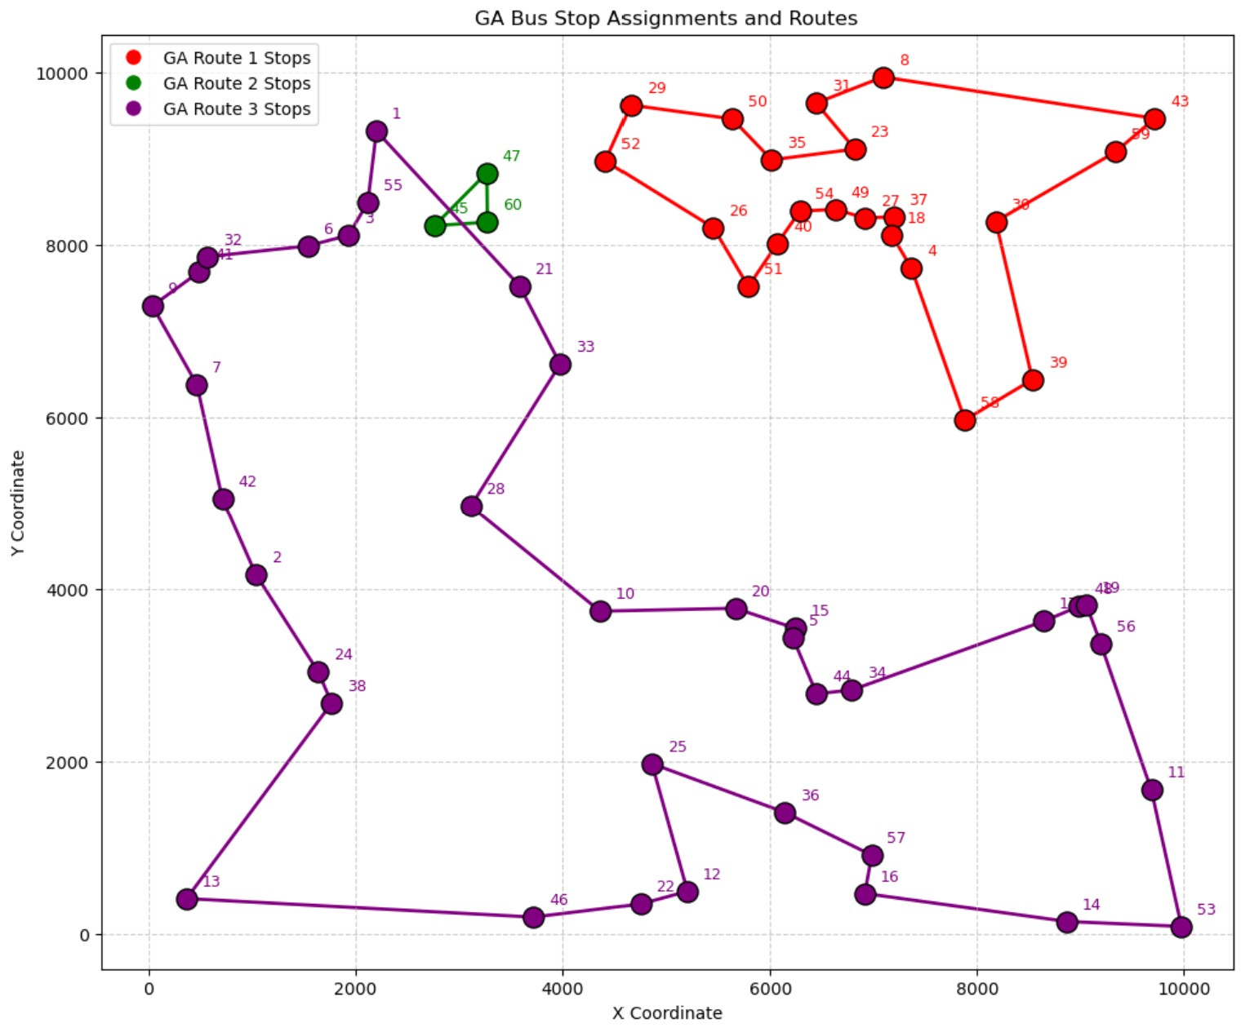
Figure 5: Solution for route maps by GA for large-scale experiment..

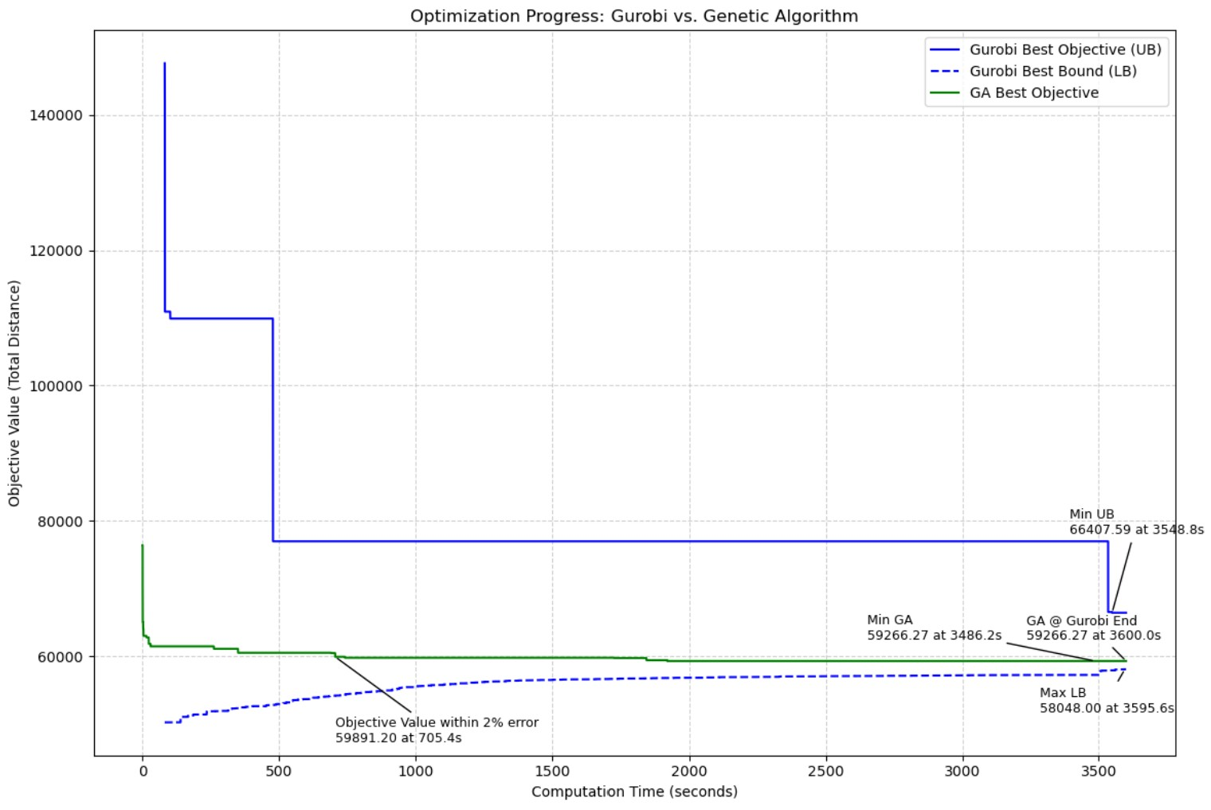
Figure 5: Objective values over time from Gurobi Solver and GA for large-scale experiment

Metric | Gurobi (Exact Solver) | GA (Metaheuristic)
Best Objective | 66407.59 | 59,266.27
Time to Reach Best | 3548.8s | 3486.2s
Gap to Best Known | +12.2% | +2.1%
Table 2: Performance comparison between Gurobi and GA for large-scale experiment

While Gurobi reports the globally best bound of 58,048.00, its best feasible solution (66407.59) was found at 3548.8s and remained unchanged. In contrast, the GA reached a much lower objective value of 59,266.27 by 3486.2s. This gives GA a significantly smaller optimality gap, indicating stronger practical performance under time constraints.

5. Insights from the experiments
The output solutions from both Gurobi and the Genetic Algorithm (GA) provide several valuable operational and strategic insights for bus route planning:

5.1 Multi-route optimisation reduces total travel time
Our problem formulation, which splits the classic Travelling Salesman Problem (TSP) into multiple routes, clearly demonstrates the benefits of multi-route assignment. By dividing 60 bus stops across 3 separate loops, the model avoids excessively long single-route tours that would lead to longer passenger wait times and operational inefficiencies.

5.2 GA is more time-effective
In larger problem instances, the GA significantly outperformed Gurobi in terms of the best feasible solution found under the same time limit. Although Gurobi provides a theoretically strong lower bound, its upper bound plateaued after 3548.8 seconds and did not improve. Meanwhile, the GA continued to explore new solutions and converged on a much better objective value, with a gap to best known of only +2.1%, compared to Gurobi's +12.2%.
This suggests that in real-world scenarios with strict decision timelines, GAs are highly effective and may provide better practical solutions than exact solvers, especially when the problem size increases.

5.3 Route distribution patterns
The GA-generated solutions reveal natural clustering of bus stops, where each route tends to cover spatially close groups of stops. This emergent behavior is aligned with efficient route planning practices in logistics and public transport. The ability of the GA to produce such practical clusters without explicit spatial constraints is an indicator of the robustness of its design.

5.4 Non-trivial routes
Constraints such as a minimum of 3 stops per route and a minimum route length of 8000 units were critical in avoiding impractical or trivial solutions. These constraints ensured that all routes were meaningfully utilized, mimicking real-world expectations such as minimum service levels per bus.

5.5 Visualisation of convergence and stagnation
The time-series plots comparing Gurobi and GA performance over time also provide visual insights. Gurobi’s early stagnation contrasts with GA’s gradual improvements, highlighting the exploratory nature of evolutionary algorithms. Annotated markers indicating the last significant drop and the time of convergence make these patterns clear for analysis and reporting.

6. Conclusion
This project tackled a modified Travelling Salesman Problem (TSP) involving the optimization of multiple bus routes to minimize total travel distance, subject to practical constraints such as minimum route length and stop assignments. By formulating the problem mathematically and solving it using both an exact solver (Gurobi) and a Genetic Algorithm (GA) metaheuristic, we were able to evaluate the strengths and trade-offs of each approach.
The Gurobi solver, while offering optimality guarantees and lower bounds, faced scalability challenges for larger problem instances. In contrast, the Genetic Algorithm demonstrated strong performance under time constraints, delivering high-quality feasible solutions with smaller optimality gaps within the same computational time. Its adaptability and efficiency make it a promising tool for real-world routing applications where exact methods may struggle.
Ultimately, the integration of domain-specific constraints with a carefully customized GA yielded practical and insightful results, confirming that well-designed metaheuristics can serve as robust alternatives to traditional solvers, especially for large-scale, time-sensitive optimization problems.

7. Presentation and proper citation of all sources
Gurobi solver (Academic license) was used as the exact optimisation solver for the evaluation of our solution.
We wish to thank Professor Cai Yu Tong for his guidance in formulating our initial problem statement, as well as his advice for simplifying the initial problem statement after considerations of time constraints, and for providing the starting code for the Genetic Algorithm (GA) from his lessons which we then referenced and modified for our project.

Appendix

[Python Code]
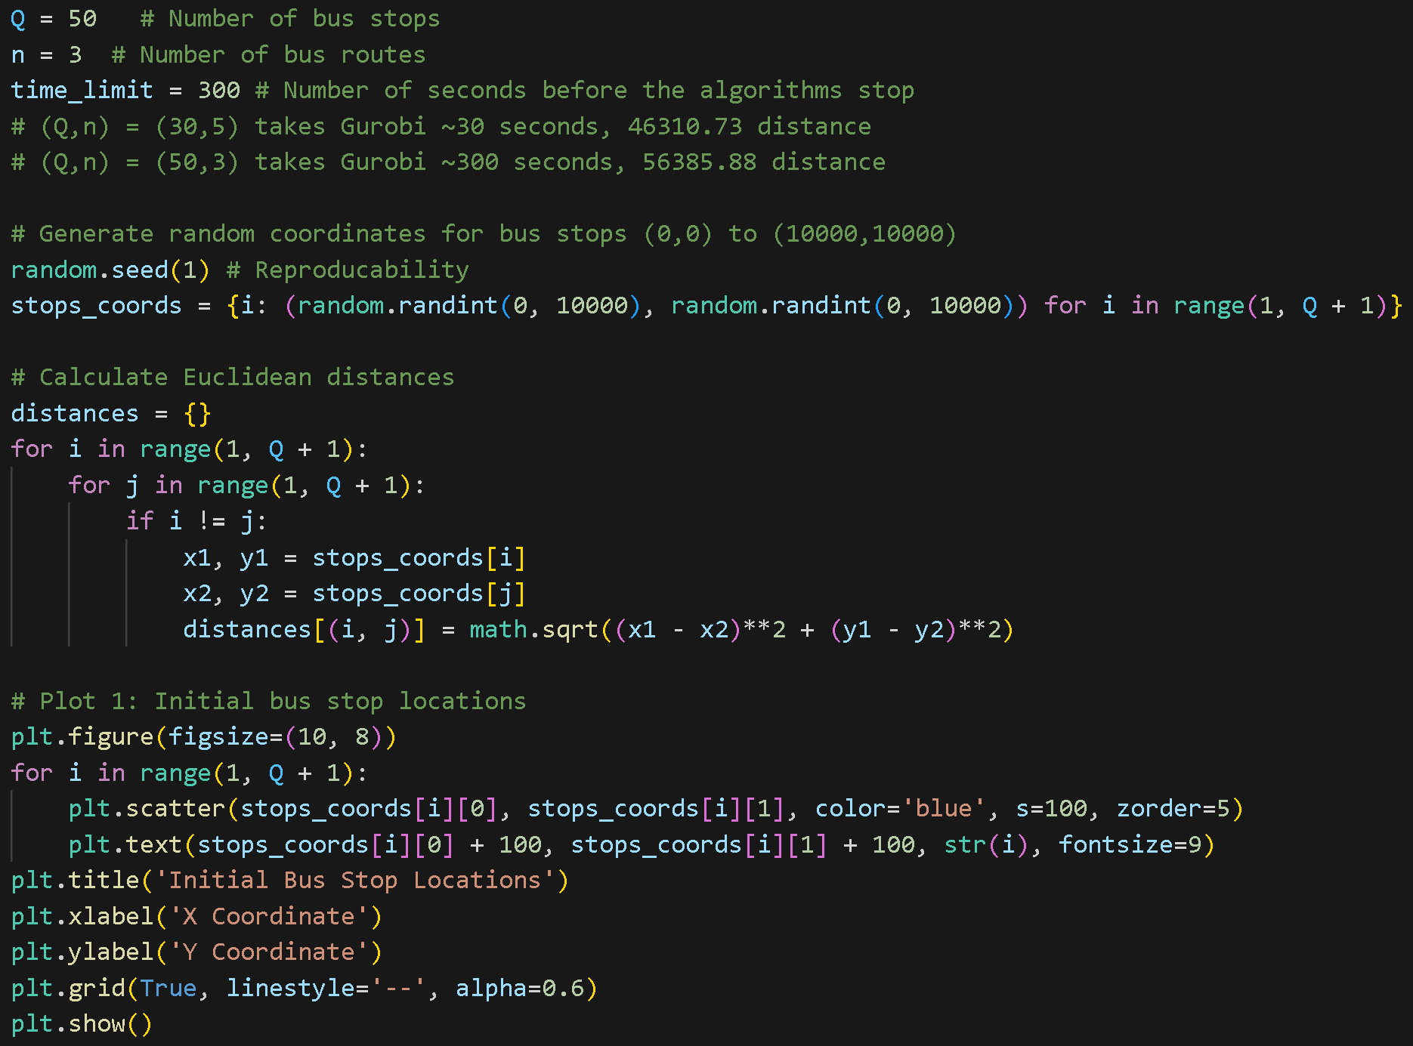
A1.1: Constants & Sets
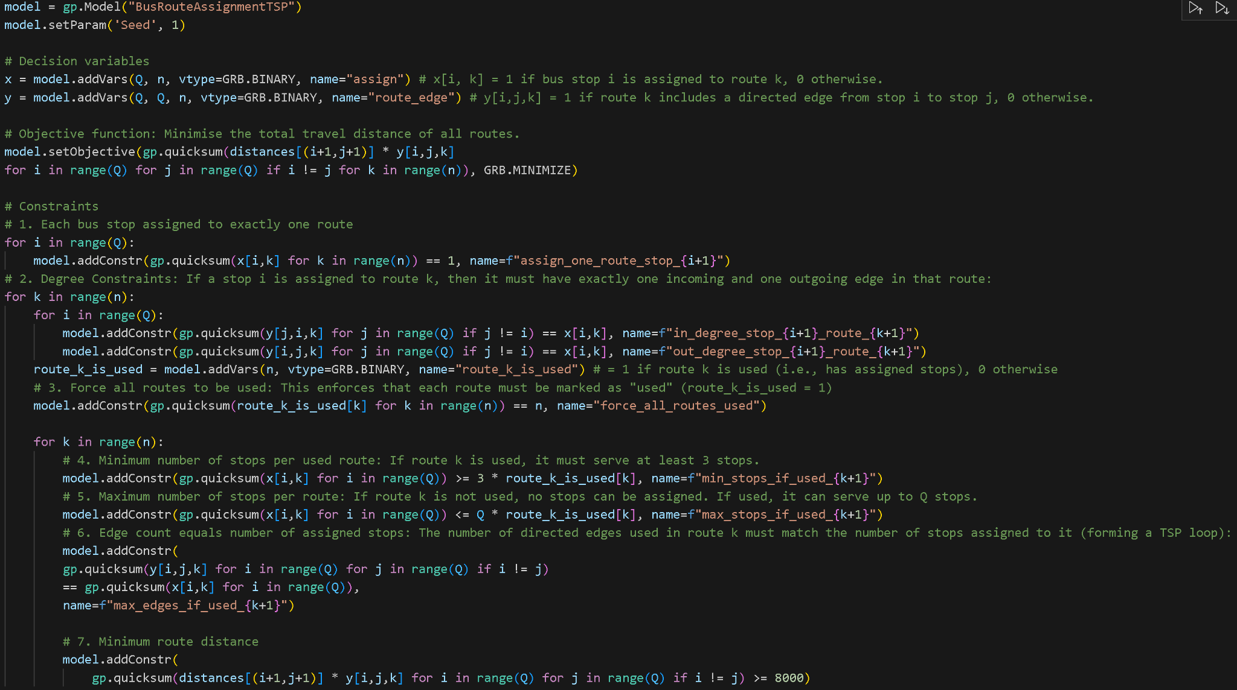
A1.2: Decision Variables & Constraints

